
Wednesday Sept 16th
APICS Maine Chapter presents:

It’s Not About You…
…It’s About How You Can Help

An Attitude Shift that Ensures Success

Gary Pezzuti – Career Placement Professional
North, Central & West Jersey APICS Chapters

Whether preparing a resume, sitting for an interview/performance review, addressing your team or presenting to the Board of Directors… it’s not about you!! Simply being good – or great – at your role is not enough. In fact it often hinders one’s growth because they approach life with a ‘Look what I can do’ and/or ‘I want… I deserve… I’m entitled to…’ attitude.

At some point in our lives, MOST of us realized that the world did not revolve around us… and what WE wanted. When the shock of this realization wore off most learned to accept this truth and still reach for our goals, albeit hampered by this restricting reality. However, some see the beauty of this arrangement as the ultimate “We all can win” approach to life including work, relationships and personal achievements.

This session's objective is to provide the innovative with specific tools to be used across life’s spectrum: from preparing resumes, conducting performance reviews, dealing with suppliers/customers, addressing top management, and asking for a raise/promotion to courting, marriage and rearing children.

We will:
- Learn how to identify what ‘they’ want
- Discuss how to present ‘Relevant Experience’.
- Examine the 80/20 and 70+/5/<25 rules
- Practice How Can I Help vs. WII-FM approaches
- Provide the tools to expand your perspective, effectiveness, and career options

“Success is not getting there… it’s earning the right to be there.” – Eric Butterworth

Who Should Attend:
- Anyone working… or thinking of working
- All those over 18 years of age
- Anyone married… or thinking of marriage
- Students seeking their first ‘real job’
- Those no longer living in a cave

This presentation contains no solicitation material

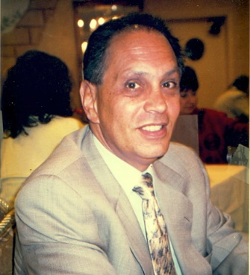
Gary Pezzuti of Summit Group has spent the past 40+ years as a Placement Professional serving most of the manufacturing sector and specializing in "Contingency Search" and "Interim Professionals". He has observed evolutionary changes in hiring procedures as well as the emergence of numerous "magical marketing techniques". And while there are no magic pills, Gary has developed an efficient method of teaching candidates more effective ‘real life’ presentation techniques... satisfying the desires of the candidates as well as fulfilling the requirements of the position and the expectations of the hiring authorities.

In addition, Gary has been a member of North Jersey APICS since 1981; presently serves as Treasurer for Central Jersey APICS and Treasurer for West Jersey APICS. He is also the 2012 APICS International Volunteer of the Year.

Gary is Past President of the Board of Unity Church of NYC, Treasurer of the Eric Butterworth Foundation and Adjutant for Military Order of the Purple Heart - Chapter 202. http://www.LinkedIn.com/in/GaryPezzutiSummitGroup

